**Comp 4320 Homework 1**

**Haden Stuart – has0027**

1. ***a.)*** **Packet switching** would be more appropriate for this since the data being transmitted is in bursts instead of a steady stream of data.

***b.)*** Since the sum of the data rates(1.64Mbps) is less than the given link capacity(1.8Mbps), **no congestion control** will be needed.

1. ***a.)*** 15Mbps = 15000 Kbps link, each user needs 500 Kbps, so we get 15000 / 500 = 30meaning a total of **30 users** can be supported.

***b.)*** The probability = **0.15**

***c.)*** So to get this we will use the equation:

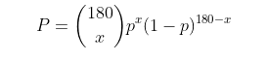

where p = 0.15 and x is the number of users transmitting.

***d.)*** To find this we can use the equation:

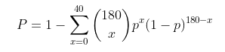

where p = 0.15 and x is the number of users transmitting per iteration of the sum.

1. In order to find the end-end delay we must use the formula:

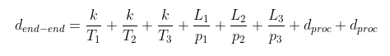

Where k = 4,000b, T(1,2,3) = 10Mbps, L1 = 2,000km, L2 = 5,000km, L3 = 3,000km, p(1,2,3) = 2.2*108m/s, dproc = 5msec. Solving for this equation we get **0.05665 sec** or **56.65 msec.**

1. To find the max throughput using only a single path we can use:

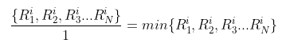

To find the max throughput using all S paths we can use the answer above divided by the total paths:  
 

1. ***a.)*** The formula for the total delay would be:

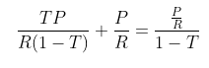

***b.)***

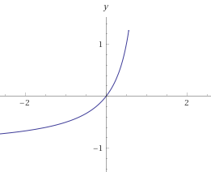

***c.)*** Given that ρ = transmission rate we get the new formula:



1. ***a.)*** (8*106) / (10*106) = **0.8sec** to get from source to first packet switch.

0.8 * 3 = **2.4sec** to get from source to destination.

***b.)*** (5*102) / (10*106) = **5*10-5sec** or **0.05msec** for the first packet to reach first switch

2 * 0.05 = **0.1msec** for the second packet to be fully received at the first switch.

***c.)*** So we know that the first packet will be received at the first switch after 0.05msec meaning that it will reach the destination at 3*0.05msec = 0.15msec. After it reaches the destination every 0.05msec another packet will reach the destination which gives us: 0.15msec + 15999 * 0.05msec = **800.1msec** to receive the entire message.

***d.)*** The main drawback of message segmentation is the need for the message to be reassembled at the destination host. This means that if a single packet is missing then the message cannot be read. This method will also use much more bandwidth